MAD LAB CYCLE 1

ATHIRA JOJO
20MCA018

Q1:DESIGN ALOGIN PAGE

PROGRAM

<LinearLayout android:layout_width="match_parent"
android:layout_height="match_parent"
android:orientation="vertical"
xmlns:android="http://schemas.android.com/apk/res/android">
<EditText
android:layout_width="match_parent"
android:layout_height="wrap_content"
android:hint="USER NAME"/>
<EditText
android:layout_width="match_parent"
android:layout_height="wrap_content"
android:hint="PASSWORD"
android:id="@+id/password"/>
<Button
android:layout_width="match_parent"
android:layout_height="wrap_content"
android:text="LOGIN"
android:id="@+id/login"/>
</LinearLayout>

OUTPUT

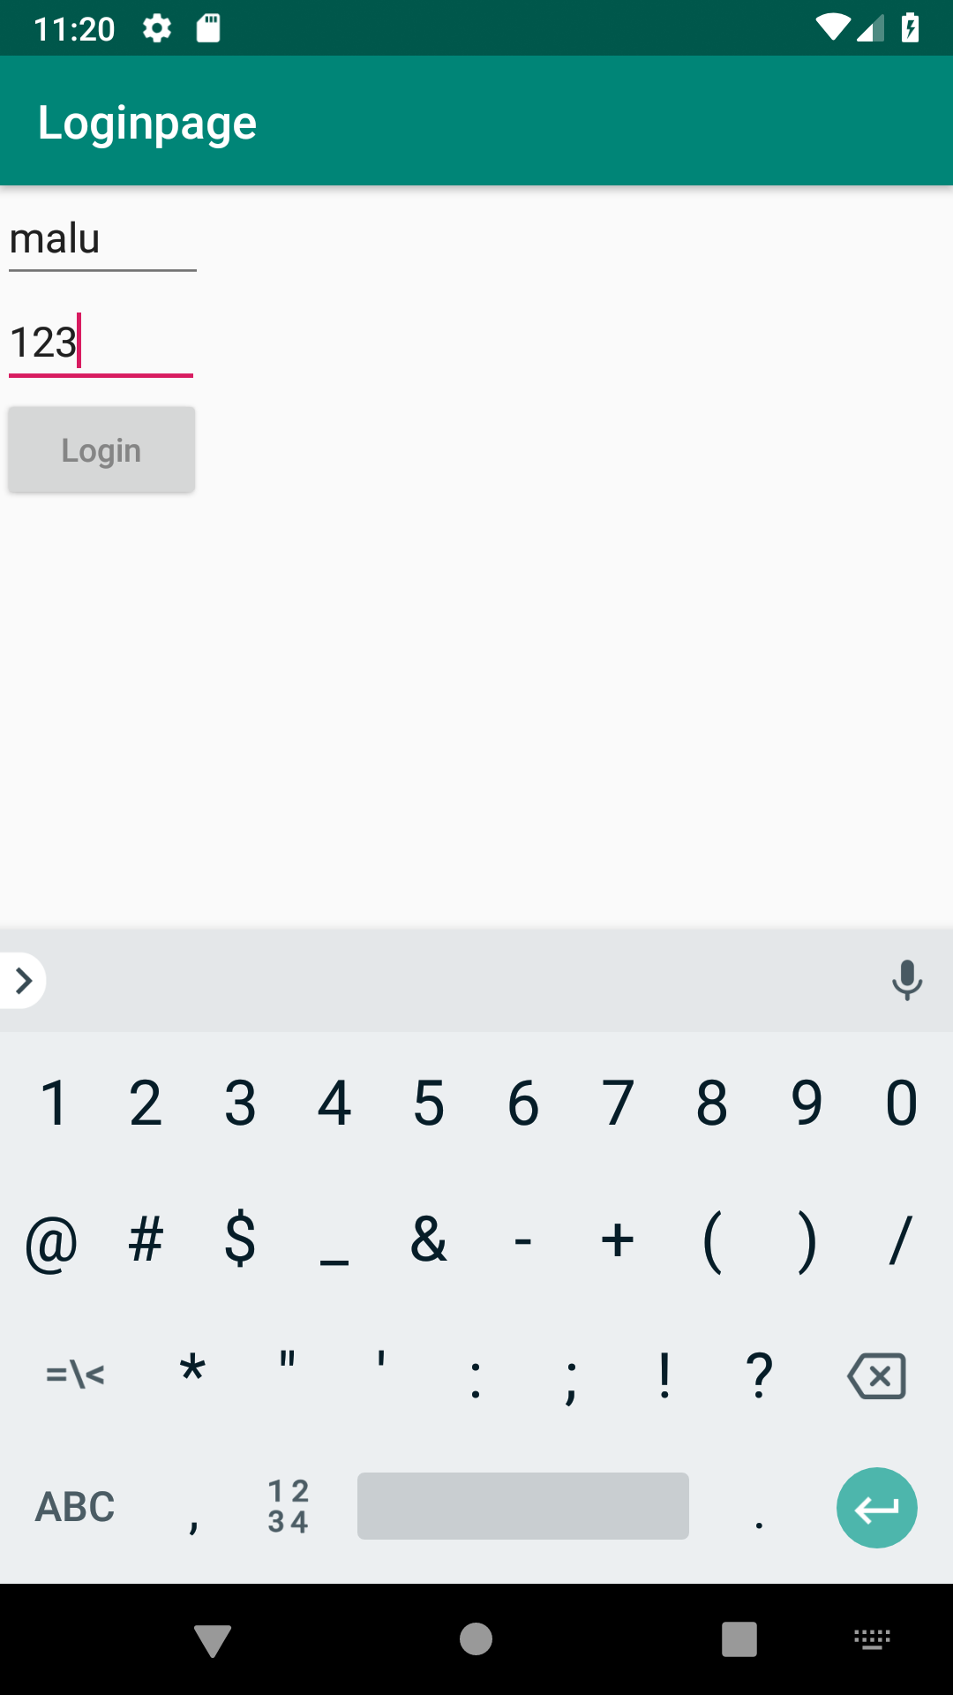

Q2:CHANGE CONTENT IN THE TEXT VIEW ON ABUTTON CLICK

PROGRAM

.XML

<LinearLayout
android:layout_width="match_parent"
android:layout_height="match_parent"
android:orientation="vertical"
android:gravity="center"
xmlns:android="http://schemas.android.com/apk/res/android">
<TextView
android:id="@+id/tv"
android:layout_width="wrap_content"
android:layout_height="wrap_content"
android:text="ANU"/>
<Button
android:id="@+id/btn1"
android:layout_width="wrap_content"
android:layout_height="wrap_content"
android:text="Change"
android:onClick="change"/>
</LinearLayout>
.JAVA
package com.example.sjcet.ChangeTheContent;
import android.os.Bundle;
import android.support.v7.app.AppCompatActivity;
import android.view.View;
import android.widget.TextView;
public class MainActivity extends AppCompatActivity {
TextView tv;
@Override
protected void onCreate(Bundle savedInstanceState) {
super.onCreate(savedInstanceState);
setContentView(R.layout.activity_main);
tv = findViewById(R.id.tv);
}
public void change(View view) {
tv.setText("Essa");
}
}
OUTPUT

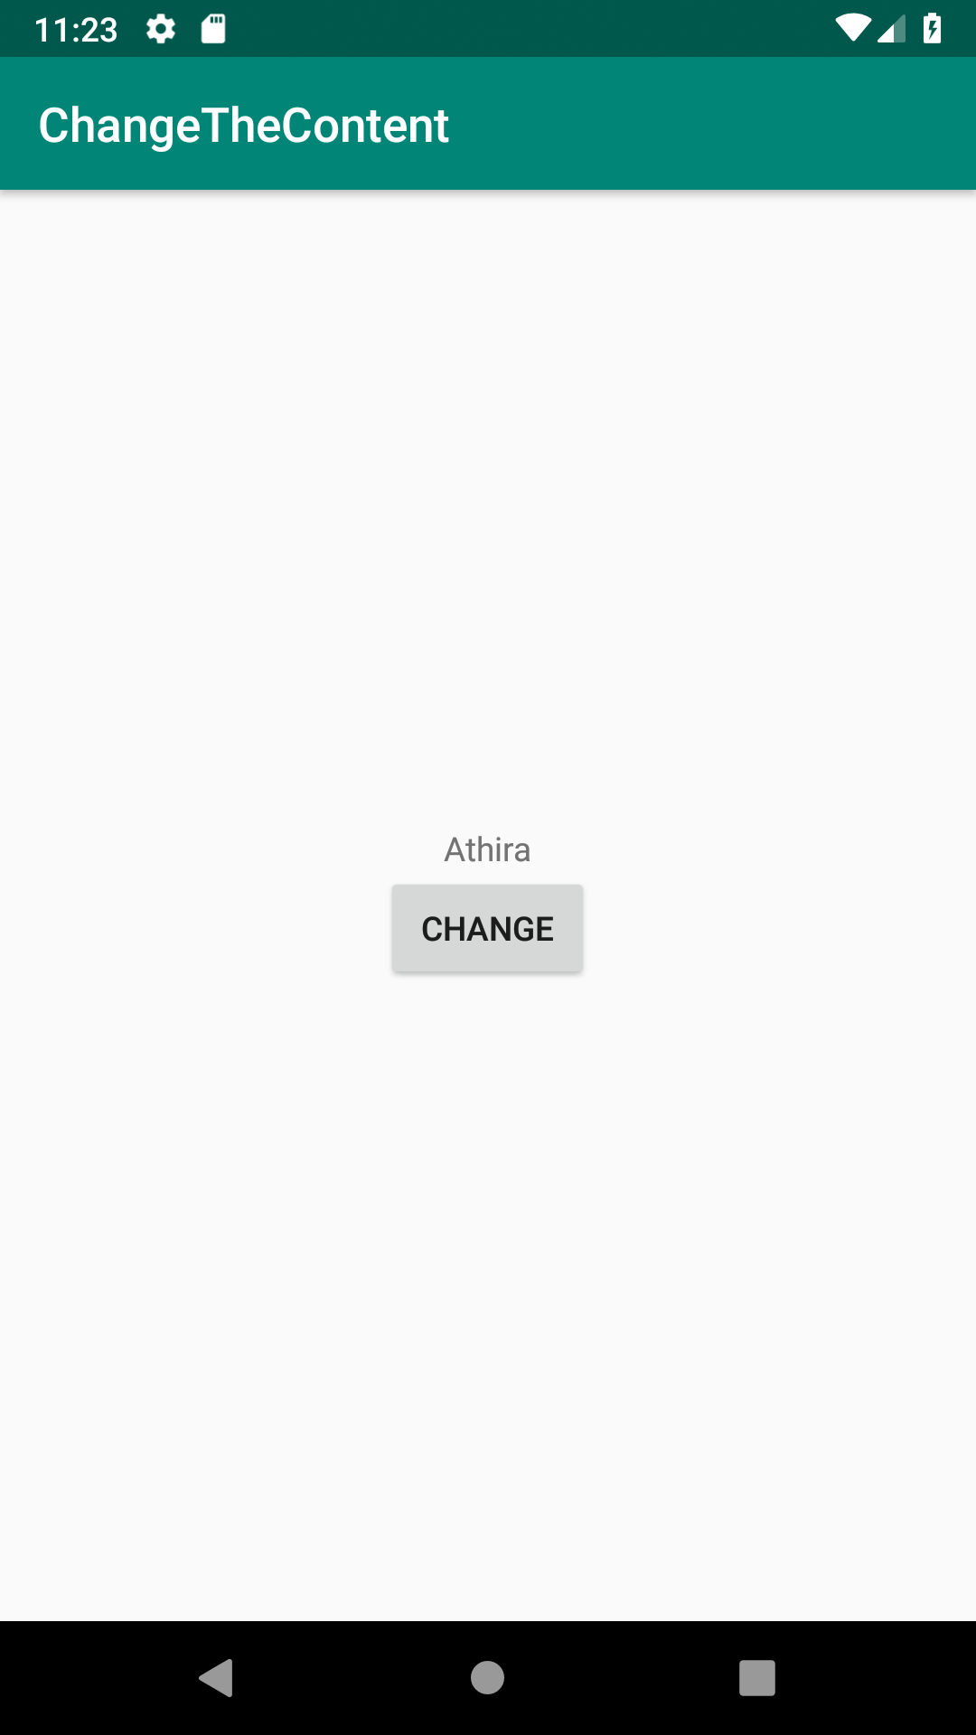

Q3: READ A VALUE FROM EDIT TEXT AND PRINT IT IN A TEXT VIEW
PROGRAM

XML:
<LinearLayout android:layout_height="match_parent" android:layout_width="match_parent"
android:orientation="vertical" android:gravity="center"
xmlns:android="http://schemas.android.com/apk/res/android">
<TextView
android:layout_width="wrap_content"
android:layout_height="wrap_content"
android:id="@+id/tv1"
android:text="Text1"/>
<EditText
android:layout_width="wrap_content"
android:layout_height="wrap_content"
android:id="@+id/et1"
android:hint="Enter the content"/>
<Button
android:layout_width="wrap_content"
android:layout_height="wrap_content"
android:id="@+id/b1"
android:text="ChangeText"
android:onClick="changeLabelContent"/>

</LinearLayout>

JAVA:

package com.example.sjcet.edittext;
import android.support.v7.app.AppCompatActivity;
import android.os.Bundle;
import android.view.View;
import android.widget.EditText;
import android.widget.TextView;
public class MainActivity extends AppCompatActivity {
TextView tv1;
EditText et1;
@Override
protected void onCreate(Bundle savedInstanceState) {
super.onCreate(savedInstanceState);
setContentView(R.layout.activity_main);
}
public void changeLabelContent(View view) {
tv1=(TextView)findViewById(R.id.tv1);
et1=(EditText)findViewById(R.id.et1);
tv1.setText(et1.getText());
}
}

OUTPUT

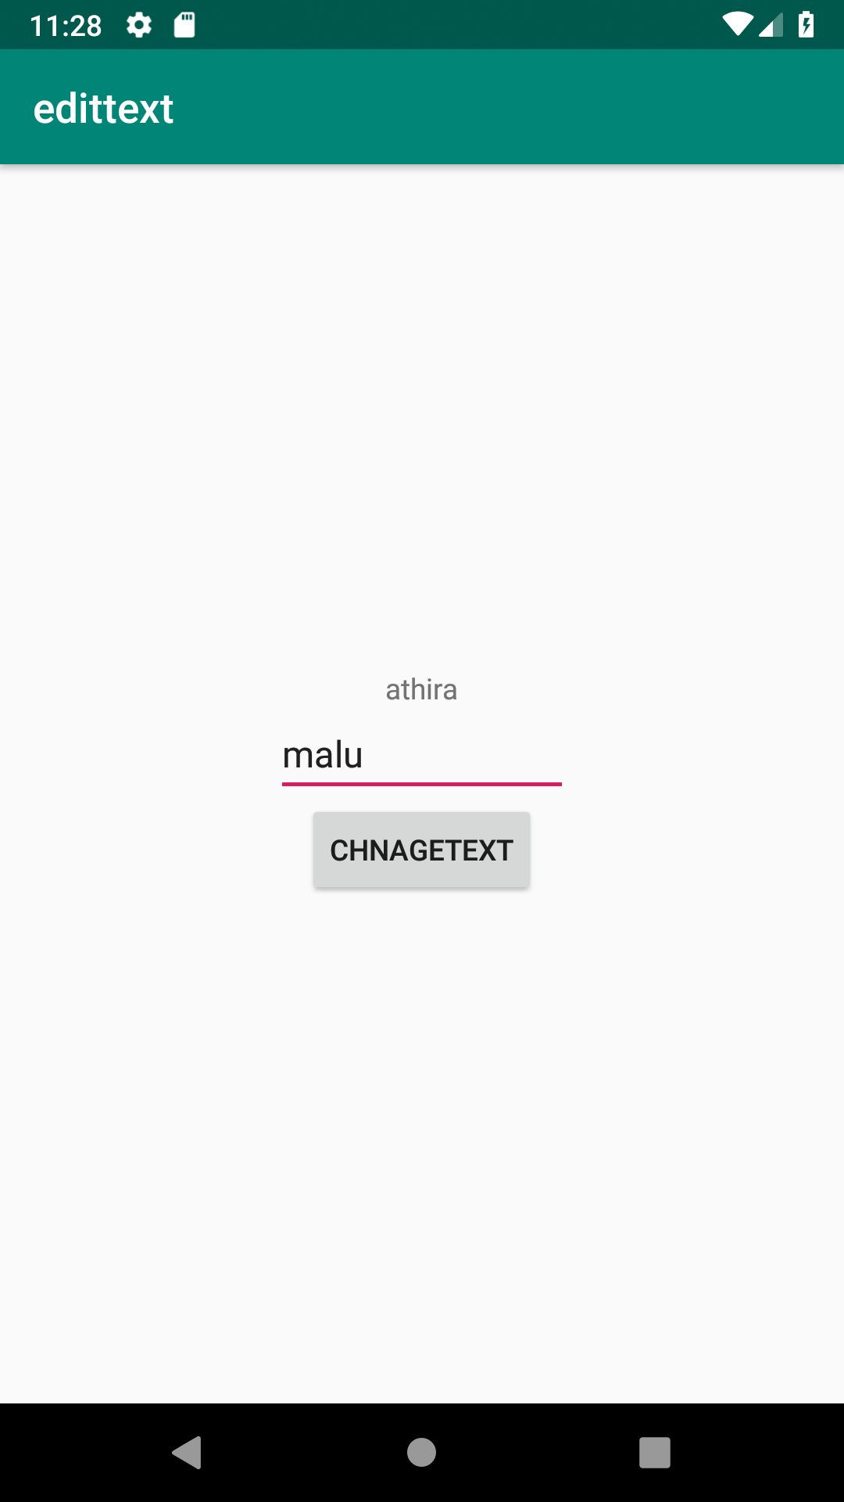

Q4:CHANGE THE BAGROUND COLOR ON A BUTTON CLICK

PROGRAM

activity_main.xml

<?xml version="1.0" encoding="utf-8"?>

<RelativeLayout
xmlns:android="http://schemas.android.com/apk/res/android"
xmlns:tools="http://schemas.android.com/tools"
android:id="@+id/rlVar1"
android:layout_width="match_parent"
android:layout_height="match_parent"
android:background="@color/green"
tools:context=".MainActivity">
<TextView
android:id="@+id/tvVar1"
android:layout_width="wrap_content"
android:layout_height="wrap_content"
android:layout_centerHorizontal="true"
android:layout_marginTop="240dp"
android:text="What whould you like?"
android:textSize="30dp"
android:textStyle="bold" />
<LinearLayout
android:layout_width="wrap_content"
android:layout_height="wrap_content"
android:layout_below="@+id/tvVar1"
android:layout_centerInParent="true"
android:layout_marginTop="60dp"
android:orientation="horizontal"
android:padding="10dp">
<Button
android:id="@+id/btVar1"
android:layout_width="150dp"
android:layout_height="wrap_content"
android:padding="20dp"
android:text="Cool"
android:textSize="25dp" />
<Button
android:id="@+id/btVar2"
android:layout_width="150dp"
android:layout_height="wrap_content"
android:padding="20dp"
android:text="Warm"
android:textSize="25dp" />
</LinearLayout>
</RelativeLayout>
main_activity.java
package com.example.sjcet.baground;

import android.os.Bundle;
import android.support.v7.app.AppCompatActivity;
import android.view.View;
import android.widget.Button;
import android.widget.RelativeLayout;
public class MainActivity extends AppCompatActivity {
@Override
protected void onCreate(Bundle savedInstanceState) {
super.onCreate(savedInstanceState);
setContentView(R.layout.activity_main);
Button button1, button2;
final RelativeLayout relativeLayout;
// set button 1 with its id
button1 = findViewById(R.id.btVar1);
// set button 2 with its id
button2 = findViewById(R.id.btVar2);
// set relative layout with its id
relativeLayout = findViewById(R.id.rlVar1);
// onClick function for button 1
button1.setOnClickListener(new View.OnClickListener() {
@Override
public void onClick(View view) {
// set the color to relative layout
relativeLayout.setBackgroundResource(R.color.cool);
}
});
// onClick function for button 2
button2.setOnClickListener(new View.OnClickListener() {
@Override
public void onClick(View view) {
// set the color to relative layout
relativeLayout.setBackgroundResource(R.color.warm);
}
});
}
}
color.xml
<?xml version="1.0" encoding="utf-8"?>
<resources>
<color name="colorPrimary">#6200EE</color>
<color name="colorPrimaryDark">#3700B3</color>
<color name="colorAccent">#03DAC5</color>
<color name="green">#0F9D58</color>
<color name="cool">#188FCF</color>
<color name="warm">#F1D416</color>
</resources>
OUTPUT
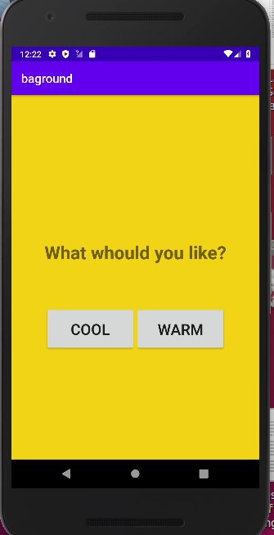

Q5:CREATE A SMPLE CALCULATOR

PROGRAM
.java
package com.example.sjcet.calculator;
import android.os.Bundle;
import android.support.v7.app.AppCompatActivity;
import android.view.View;
import android.widget.Button;
import android.widget.EditText;
public class MainActivity extends AppCompatActivity {
Button button0, button1, button2, button3, button4, button5, button6,
button7, button8, button9, buttonAdd, buttonSub, buttonDivision,
buttonMul, button10, buttonC, buttonEqual;
EditText crunchifyEditText;
float mValueOne, mValueTwo;
boolean crunchifyAddition, mSubtract, crunchifyMultiplication, crunchifyDivision;
@Override
protected void onCreate(Bundle savedInstanceState) {
super.onCreate(savedInstanceState);
setContentView(R.layout.activity_main);
button0 = (Button) findViewById(R.id.button0);
button1 = (Button) findViewById(R.id.button1);
button2 = (Button) findViewById(R.id.button2);
button3 = (Button) findViewById(R.id.button3);
button4 = (Button) findViewById(R.id.button4);
button5 = (Button) findViewById(R.id.button5);
button6 = (Button) findViewById(R.id.button6);
button7 = (Button) findViewById(R.id.button7);
button8 = (Button) findViewById(R.id.button8);
button9 = (Button) findViewById(R.id.button9);
button10 = (Button) findViewById(R.id.button10);
buttonAdd = (Button) findViewById(R.id.buttonadd);
buttonSub = (Button) findViewById(R.id.buttonsub);
buttonMul = (Button) findViewById(R.id.buttonmul);
buttonDivision = (Button) findViewById(R.id.buttondiv);
buttonC = (Button) findViewById(R.id.buttonC);
buttonEqual = (Button) findViewById(R.id.buttoneql);
crunchifyEditText = (EditText) findViewById(R.id.edt1);
button1.setOnClickListener(new View.OnClickListener() {
@Override
public void onClick(View v) {
crunchifyEditText.setText(crunchifyEditText.getText() + "1");
}
});
button2.setOnClickListener(new View.OnClickListener() {
@Override
public void onClick(View v) {
crunchifyEditText.setText(crunchifyEditText.getText() + "2");
}
});
button3.setOnClickListener(new View.OnClickListener() {
@Override
public void onClick(View v) {
crunchifyEditText.setText(crunchifyEditText.getText() + "3");
}
});
button4.setOnClickListener(new View.OnClickListener() {
@Override
public void onClick(View v) {
crunchifyEditText.setText(crunchifyEditText.getText() + "4");
}
});
button5.setOnClickListener(new View.OnClickListener() {
@Override
public void onClick(View v) {
crunchifyEditText.setText(crunchifyEditText.getText() + "5");
}
});
button6.setOnClickListener(new View.OnClickListener() {
@Override
public void onClick(View v) {
crunchifyEditText.setText(crunchifyEditText.getText() + "6");
}
});
button7.setOnClickListener(new View.OnClickListener() {
@Override
public void onClick(View v) {
crunchifyEditText.setText(crunchifyEditText.getText() + "7");
}
});
button8.setOnClickListener(new View.OnClickListener() {
@Override
public void onClick(View v) {
crunchifyEditText.setText(crunchifyEditText.getText() + "8");
}
});
button9.setOnClickListener(new View.OnClickListener() {
@Override
public void onClick(View v) {
crunchifyEditText.setText(crunchifyEditText.getText() + "9");
}
});
button0.setOnClickListener(new View.OnClickListener() {
@Override
public void onClick(View v) {
crunchifyEditText.setText(crunchifyEditText.getText() + "0");
}
});
buttonAdd.setOnClickListener(new View.OnClickListener() {
@Override
public void onClick(View v) {
if (crunchifyEditText == null) {
crunchifyEditText.setText("");
} else {
mValueOne = Float.parseFloat(crunchifyEditText.getText() + "");
crunchifyAddition = true;
crunchifyEditText.setText(null);
}
}
});
buttonSub.setOnClickListener(new View.OnClickListener() {
@Override
public void onClick(View v) {
mValueOne = Float.parseFloat(crunchifyEditText.getText() + "");
mSubtract = true;
crunchifyEditText.setText(null);
}
});
buttonMul.setOnClickListener(new View.OnClickListener() {
@Override
public void onClick(View v) {
mValueOne = Float.parseFloat(crunchifyEditText.getText() + "");
crunchifyMultiplication = true;
crunchifyEditText.setText(null);
}
});
buttonDivision.setOnClickListener(new View.OnClickListener() {
@Override
public void onClick(View v) {
mValueOne = Float.parseFloat(crunchifyEditText.getText() + "");
crunchifyDivision = true;
crunchifyEditText.setText(null);
}
});
buttonEqual.setOnClickListener(new View.OnClickListener() {
@Override
public void onClick(View v) {
mValueTwo = Float.parseFloat(crunchifyEditText.getText() + "");
if (crunchifyAddition == true) {
crunchifyEditText.setText(mValueOne + mValueTwo + "");
crunchifyAddition = false;
}
if (mSubtract == true) {
crunchifyEditText.setText(mValueOne - mValueTwo + "");
mSubtract = false;
}
if (crunchifyMultiplication == true) {
crunchifyEditText.setText(mValueOne * mValueTwo + "");
crunchifyMultiplication = false;
}
if (crunchifyDivision == true) {
crunchifyEditText.setText(mValueOne / mValueTwo + "");
crunchifyDivision = false;
}
}
});
buttonC.setOnClickListener(new View.OnClickListener() {
@Override
public void onClick(View v) {
crunchifyEditText.setText("");
}
});
button10.setOnClickListener(new View.OnClickListener() {
@Override
public void onClick(View v) {
crunchifyEditText.setText(crunchifyEditText.getText() + ".");
}
});
}
}
.xml
<RelativeLayout xmlns:android="http://schemas.android.com/apk/res/android"
xmlns:tools="http://schemas.android.com/tools"
android:id="@+id/relative1"
android:layout_width="match_parent"
android:layout_height="match_parent"
tools:context=".MainActivity">
<EditText
android:id="@+id/edt1"
android:layout_width="match_parent"
android:layout_height="wrap_content" />
<Button
android:id="@+id/button1"
style="?android:attr/buttonStyleSmall"
android:layout_width="wrap_content"
android:layout_height="wrap_content"
android:layout_alignEnd="@+id/button4"
android:layout_alignRight="@+id/button4"
android:layout_below="@+id/edt1"
android:layout_marginTop="94dp"
android:text="1" />
<Button
android:id="@+id/button2"
style="?android:attr/buttonStyleSmall"
android:layout_width="wrap_content"
android:layout_height="wrap_content"
android:layout_alignTop="@+id/button1"
android:layout_toLeftOf="@+id/button3"
android:layout_toStartOf="@+id/button3"
android:text="2" />
<Button
android:id="@+id/button3"
style="?android:attr/buttonStyleSmall"
android:layout_width="wrap_content"
android:layout_height="wrap_content"
android:layout_alignTop="@+id/button2"
android:layout_centerHorizontal="true"
android:text="3" />
<Button
android:id="@+id/button4"
style="?android:attr/buttonStyleSmall"
android:layout_width="wrap_content"
android:layout_height="wrap_content"
android:layout_below="@+id/button1"
android:layout_toLeftOf="@+id/button2"
android:text="4" />
<Button
android:id="@+id/button5"
style="?android:attr/buttonStyleSmall"
android:layout_width="wrap_content"
android:layout_height="wrap_content"
android:layout_alignBottom="@+id/button4"
android:layout_alignLeft="@+id/button2"
android:layout_alignStart="@+id/button2"
android:text="5" />
<Button
android:id="@+id/button6"
style="?android:attr/buttonStyleSmall"
android:layout_width="wrap_content"
android:layout_height="wrap_content"
android:layout_alignLeft="@+id/button3"
android:layout_alignStart="@+id/button3"
android:layout_below="@+id/button3"
android:text="6" />
<Button
android:id="@+id/button7"
style="?android:attr/buttonStyleSmall"
android:layout_width="wrap_content"
android:layout_height="wrap_content"
android:layout_below="@+id/button4"
android:layout_toLeftOf="@+id/button2"
android:text="7" />
<Button
android:id="@+id/button8"
style="?android:attr/buttonStyleSmall"
android:layout_width="wrap_content"
android:layout_height="wrap_content"
android:layout_alignLeft="@+id/button5"
android:layout_alignStart="@+id/button5"
android:layout_below="@+id/button5"
android:text="8" />
<Button
android:id="@+id/button9"
style="?android:attr/buttonStyleSmall"
android:layout_width="wrap_content"
android:layout_height="wrap_content"
android:layout_alignLeft="@+id/button6"
android:layout_alignStart="@+id/button6"
android:layout_below="@+id/button6"
android:text="9" />
<Button
android:id="@+id/buttonadd"
style="?android:attr/buttonStyleSmall"
android:layout_width="wrap_content"
android:layout_height="wrap_content"
android:layout_alignEnd="@+id/edt1"
android:layout_alignRight="@+id/edt1"
android:layout_alignTop="@+id/button3"
android:layout_marginLeft="46dp"
android:layout_marginStart="46dp"
android:layout_toRightOf="@+id/button3"
android:text="+" />
<Button
android:id="@+id/buttonsub"
style="?android:attr/buttonStyleSmall"
android:layout_width="wrap_content"
android:layout_height="wrap_content"
android:layout_alignEnd="@+id/buttonadd"
android:layout_alignLeft="@+id/buttonadd"
android:layout_alignRight="@+id/buttonadd"
android:layout_alignStart="@+id/buttonadd"
android:layout_below="@+id/buttonadd"
android:text="-" />
<Button
android:id="@+id/buttonmul"
style="?android:attr/buttonStyleSmall"
android:layout_width="wrap_content"
android:layout_height="wrap_content"
android:layout_alignLeft="@+id/buttonsub"
android:layout_alignParentEnd="true"
android:layout_alignParentRight="true"
android:layout_alignStart="@+id/buttonsub"
android:layout_below="@+id/buttonsub"
android:text="*" />
<Button
android:id="@+id/button10"
style="?android:attr/buttonStyleSmall"
android:layout_width="wrap_content"
android:layout_height="wrap_content"
android:layout_below="@+id/button7"
android:layout_toLeftOf="@+id/button2"
android:text="." />
<Button
android:id="@+id/button0"
style="?android:attr/buttonStyleSmall"
android:layout_width="wrap_content"
android:layout_height="wrap_content"
android:layout_alignLeft="@+id/button8"
android:layout_alignStart="@+id/button8"
android:layout_below="@+id/button8"
android:text="0" />
<Button
android:id="@+id/buttonC"
style="?android:attr/buttonStyleSmall"
android:layout_width="wrap_content"
android:layout_height="wrap_content"
android:layout_alignLeft="@+id/button9"
android:layout_alignStart="@+id/button9"
android:layout_below="@+id/button9"
android:text="C" />
<Button
android:id="@+id/buttondiv"
style="?android:attr/buttonStyleSmall"
android:layout_width="wrap_content"
android:layout_height="wrap_content"
android:layout_alignEnd="@+id/buttonmul"
android:layout_alignLeft="@+id/buttonmul"
android:layout_alignRight="@+id/buttonmul"
android:layout_alignStart="@+id/buttonmul"
android:layout_below="@+id/buttonmul"
android:text="/" />
<Button
android:id="@+id/buttoneql"
android:layout_width="wrap_content"
android:layout_height="wrap_content"
android:layout_alignEnd="@+id/buttondiv"
android:layout_alignLeft="@+id/button10"
android:layout_alignRight="@+id/buttondiv"
android:layout_alignStart="@+id/button10"
android:layout_below="@+id/button0"
android:layout_marginTop="37dp"
android:text="=" />
</RelativeLayout>
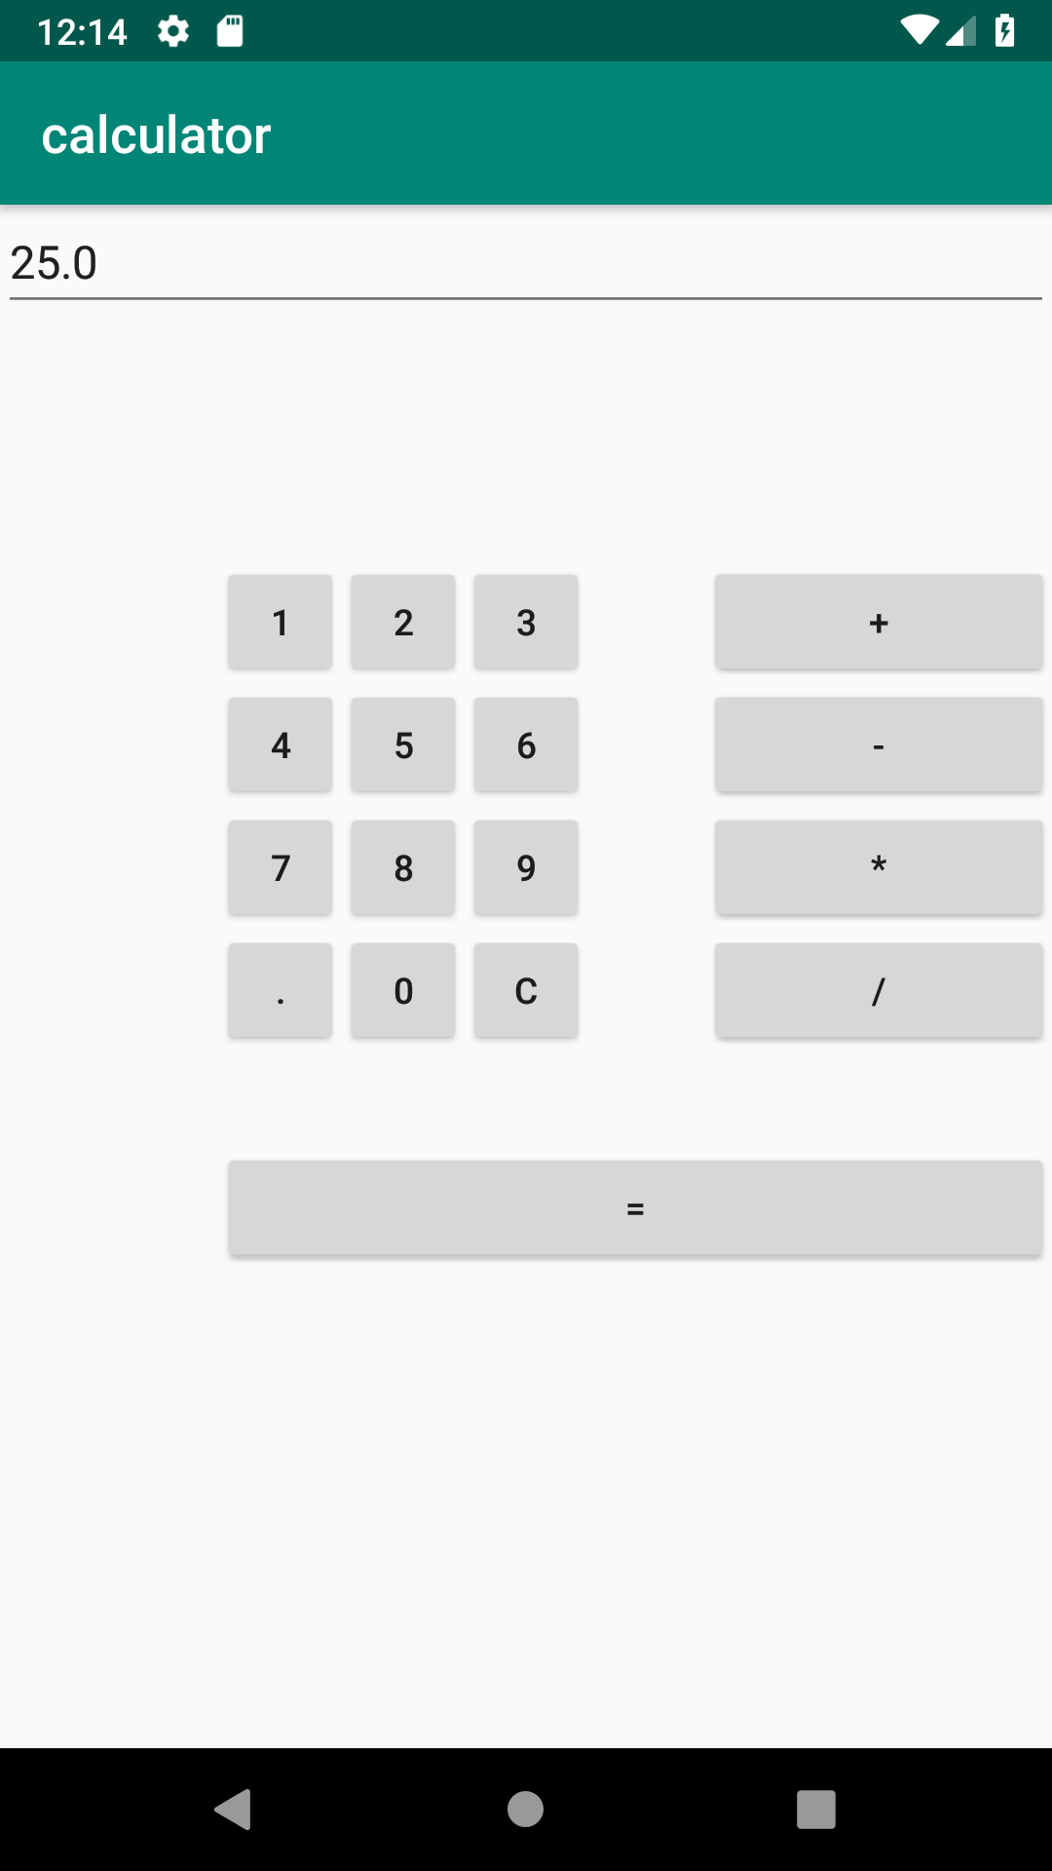
OUTPUT

MAD LAB CYCLE 2

- Create 2 Activities from 1st Activity on click move to 2nd activity (Using Intent)
code:
Activity1:
XML
<?xml version="1.0" encoding="utf-8"?>
<LinearLayout
android:id="@+id/p1"
android:layout_width="match_parent"
android:layout_height="match_parent"
android:orientation="vertical"
android:gravity="center"
xmlns:android="http://schemas.android.com/apk/res/android">
<Button
android:id="@+id/btn"
android:layout_width="wrap_content"
android:layout_height="wrap_content"
android:gravity="center"
android:onClick="click"
android:text="Click"/>
</LinearLayout>
JAVA
package com.example.sjcet.firstactivitymove;
import android.support.v7.app.AppCompatActivity;
import android.os.Bundle;
import android.view.View;
import android.content.Intent;
import android.widget.Button;
public class MainActivity extends AppCompatActivity {
Button btn;
@Override
protected void onCreate(Bundle savedInstanceState) {
super.onCreate(savedInstanceState);
setContentView(R.layout.activity_main);
btn = findViewById(R.id.btn);
}
public void click(View view) {
Opennewactivity();
}
public void Opennewactivity()
{
Intent intent=new Intent(this,MainActivity.class);
startActivity(intent);
}
}
Activity2:
XML
<?xml version="1.0" encoding="utf-8"?>
<android.support.constraint.ConstraintLayout xmlns:android="http://schemas.android.com/apk/res/android"
xmlns:app="http://schemas.android.com/apk/res-auto"
xmlns:tools="http://schemas.android.com/tools"
android:layout_width="match_parent"
android:layout_height="match_parent"
android:layout_gravity="center"
tools:context=".Main2Activity">
<TextView
android:layout_width="wrap_content"
android:layout_height="wrap_content"
android:gravity="center"
android:text="activity 2"
tools:layout_editor_absoluteX="164dp"
tools:layout_editor_absoluteY="237dp" />
</android.support.constraint.ConstraintLayout>
JAVA
package com.example.sjcet.firstactivitymove;
import android.support.v7.app.AppCompatActivity;
import android.os.Bundle;
public class Main2Activity extends AppCompatActivity {
@Override
protected void onCreate(Bundle savedInstanceState) {
super.onCreate(savedInstanceState);
setContentView(R.layout.activity_main2);
}
}
output

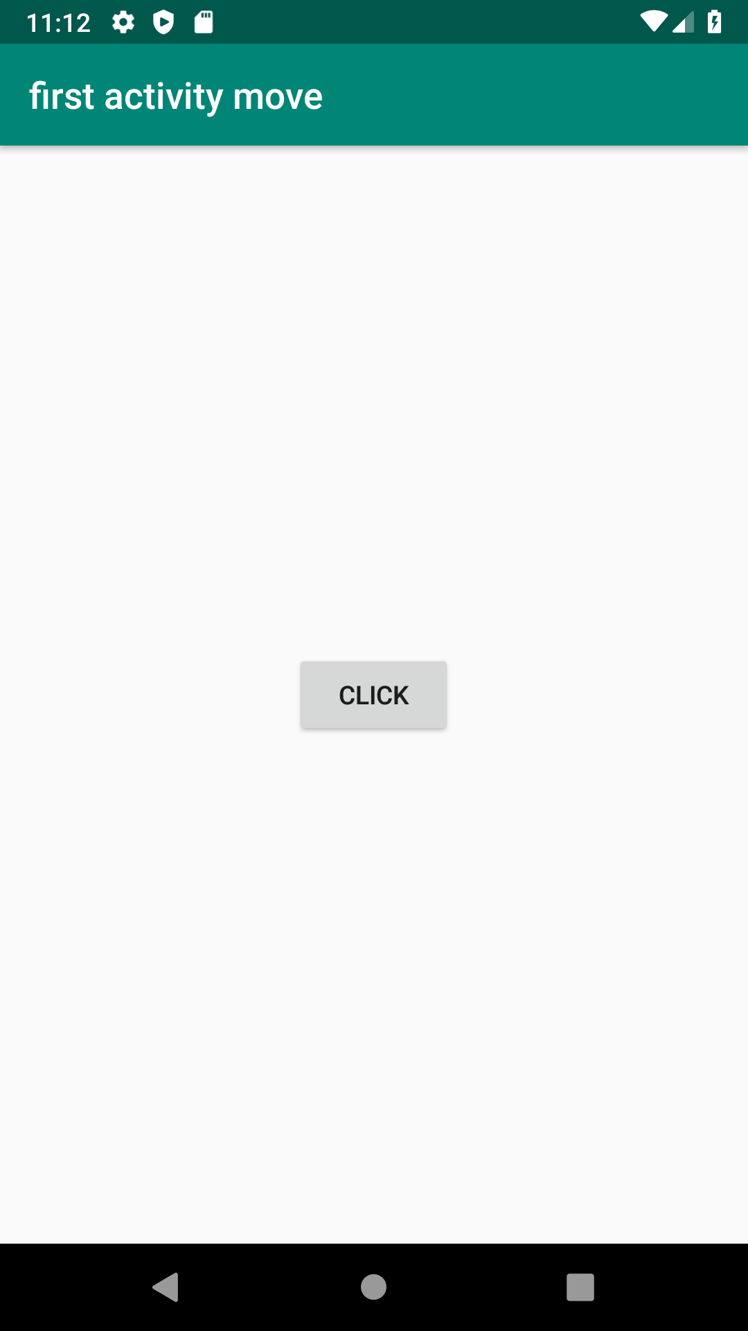

- Create an Activity and move to facebook login page on a button click(making use of Intent).
CODE:
XML
<?xml version="1.0" encoding="utf-8"?>
<LinearLayout
android:layout_height="match_parent"
xmlns:android="http://schemas.android.com/apk/res/android"
android:layout_width="match_parent"
android:orientation="horizontal"
android:gravity="center">
<Button
android:layout_width="wrap_content"
android:layout_height="wrap_content"
android:id="@+id/btn"
android:text="FaceBook Login"
android:onClick="FBLogin"
android:gravity="center"/>
</LinearLayout>
JAVA:
package com.example.sjcet.facebook;
import android.content.Intent;
import android.net.Uri;
import android.support.v7.app.AppCompatActivity;
import android.os.Bundle;
import android.view.View;
import android.widget.Button;
public class MainActivity extends AppCompatActivity {
Button btn;
@Override
protected void onCreate(Bundle savedInstanceState) {
super.onCreate(savedInstanceState);
setContentView(R.layout.activity_main);
btn = findViewById(R.id.btn);
btn.setOnClickListener(new View.OnClickListener() {
@Override
public void onClick(View v) {
Intent intent = new Intent(Intent.ACTION_VIEW,Uri.parse("https://www.facebook.com/"));
startActivity(intent);
}
});
}
}
OUTPUT:
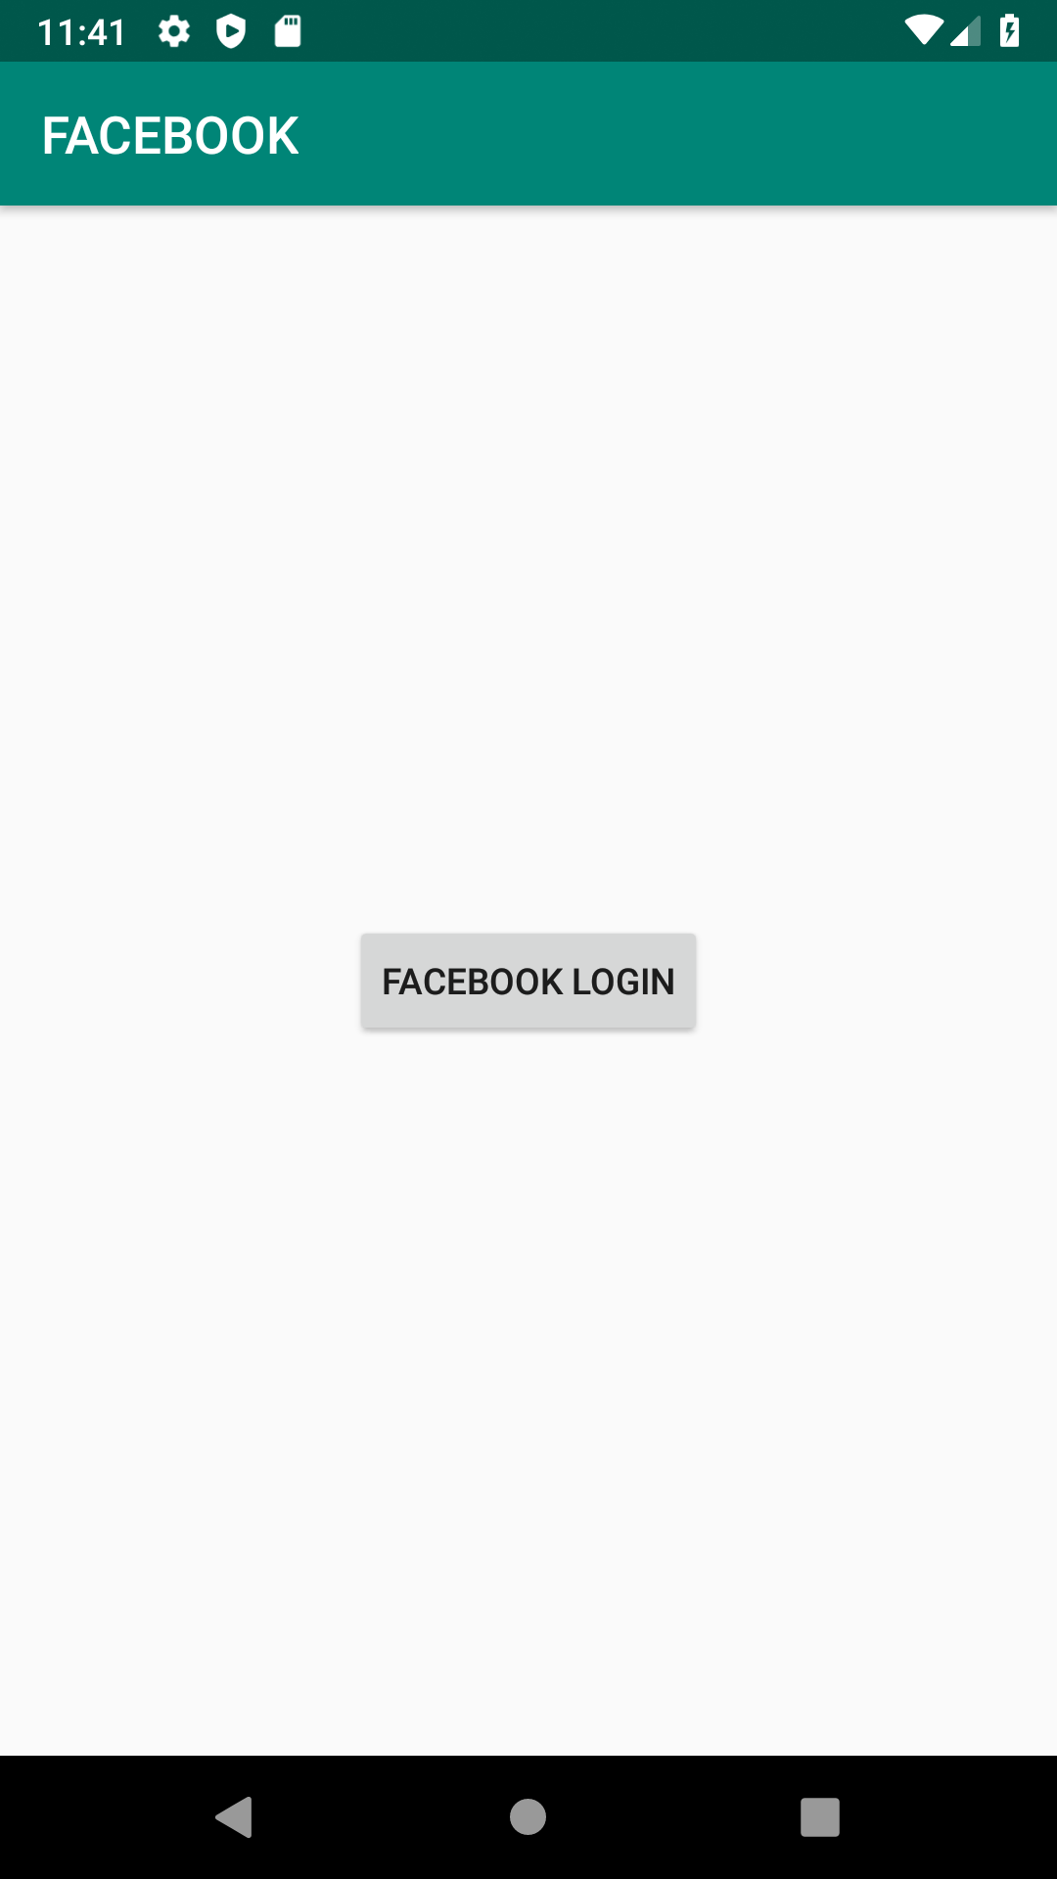

- Read message from 1st Activity and pass it onto the 2nd Activity on a button click.
Code:
activity_first_activity.xml
<?xml version="1.0" encoding="utf-8"?>
<RelativeLayout
xmlns:android="http://schemas.android.com/apk/res/android"
xmlns:app="http://schemas.android.com/apk/res-auto"
xmlns:tools="http://schemas.android.com/tools"
android:layout_width="match_parent"
android:layout_height="match_parent"
tools:context=".activity_first_activity">
<EditText
android:id="@+id/send_text_id"
android:layout_width="300dp"
android:layout_height="wrap_content"
android:textSize="25dp"
android:hint="Input"
android:textStyle="bold"
android:layout_marginTop="20dp"
android:layout_marginLeft="40dp"/>
<Button
android:id="@+id/send_button_id"
android:layout_width="wrap_content"
android:layout_height="40dp"
android:text="send"
android:textStyle="bold"
android:layout_marginTop="150dp"
android:layout_marginLeft="150dp"/>
</RelativeLayout>
activity_first_activity.java
package com.example.sjcet.twoactivity;
import android.content.Intent;
import android.support.v7.app.AppCompatActivity;
import android.os.Bundle;
import android.view.View;
import android.widget.Button;
import android.widget.EditText;
public class activity_first_activity extends AppCompatActivity {
// define the variable
Button send_button;
EditText send_text;
@Override
protected void onCreate(Bundle savedInstanceState)
{
super.onCreate(savedInstanceState);
setContentView(R.layout.activity_first_activity);
send_button = (Button)findViewById(R.id.send_button_id);
send_text = (EditText)findViewById(R.id.send_text_id);
// add the OnClickListener in sender button
// after clicked this button following Instruction will run
send_button.setOnClickListener(new View.OnClickListener() {
@Override
public void onClick(View v)
{
// get the value which input by user in EditText
// and convert it to string
String str = send_text.getText().toString();
// Create the Intent object of this class Context() to Second_activity class
Intent intent = new Intent(getApplicationContext(),second_activity.class);
// now by putExtra method put the value in key, value pair
// key is message_key by this key we will receive the value, and put the string
intent.putExtra("message_key", str);
// start the Intent
startActivity(intent);
}
});
}
}
activity_second_activity.xml
<?xml version="1.0" encoding="utf-8"?>
<RelativeLayout xmlns:android="http://schemas.android.com/apk/res/android"
xmlns:app="http://schemas.android.com/apk/res-auto"
xmlns:tools="http://schemas.android.com/tools"
android:layout_width="match_parent"
android:layout_height="match_parent"
tools:context="com.example.sjcet.twoactivity.second_activity">
<TextView
android:id="@+id/received_value_id"
android:layout_width="300dp"
android:layout_height="50dp"
android:textStyle="bold"
android:textSize="40dp"
android:layout_marginTop="20dp"
android:layout_marginLeft="40dp"/>
</RelativeLayout>
second_activity.java
package com.example.sjcet.twoactivity;
import android.content.Intent;
import android.support.v7.app.AppCompatActivity;
import android.os.Bundle;
import android.widget.TextView;
public class second_activity extends AppCompatActivity {
TextView receiver_msg;
@Override
protected void onCreate(Bundle savedInstanceState)
{
super.onCreate(savedInstanceState);
setContentView(R.layout.activity_second_activity);
receiver_msg = (TextView)findViewById(R.id.received_value_id);
// create the get Intent object
Intent intent = getIntent();
// receive the value by getStringExtra() method
// and key must be same which is send by first activity
String str = intent.getStringExtra("message_key");
// display the string into textView
receiver_msg.setText(str);
}
}
output:

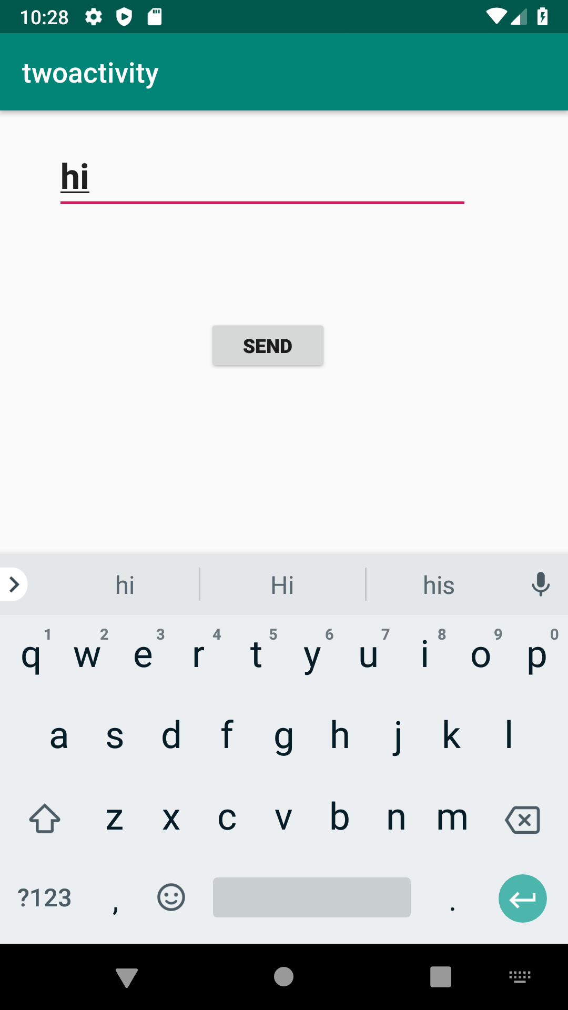
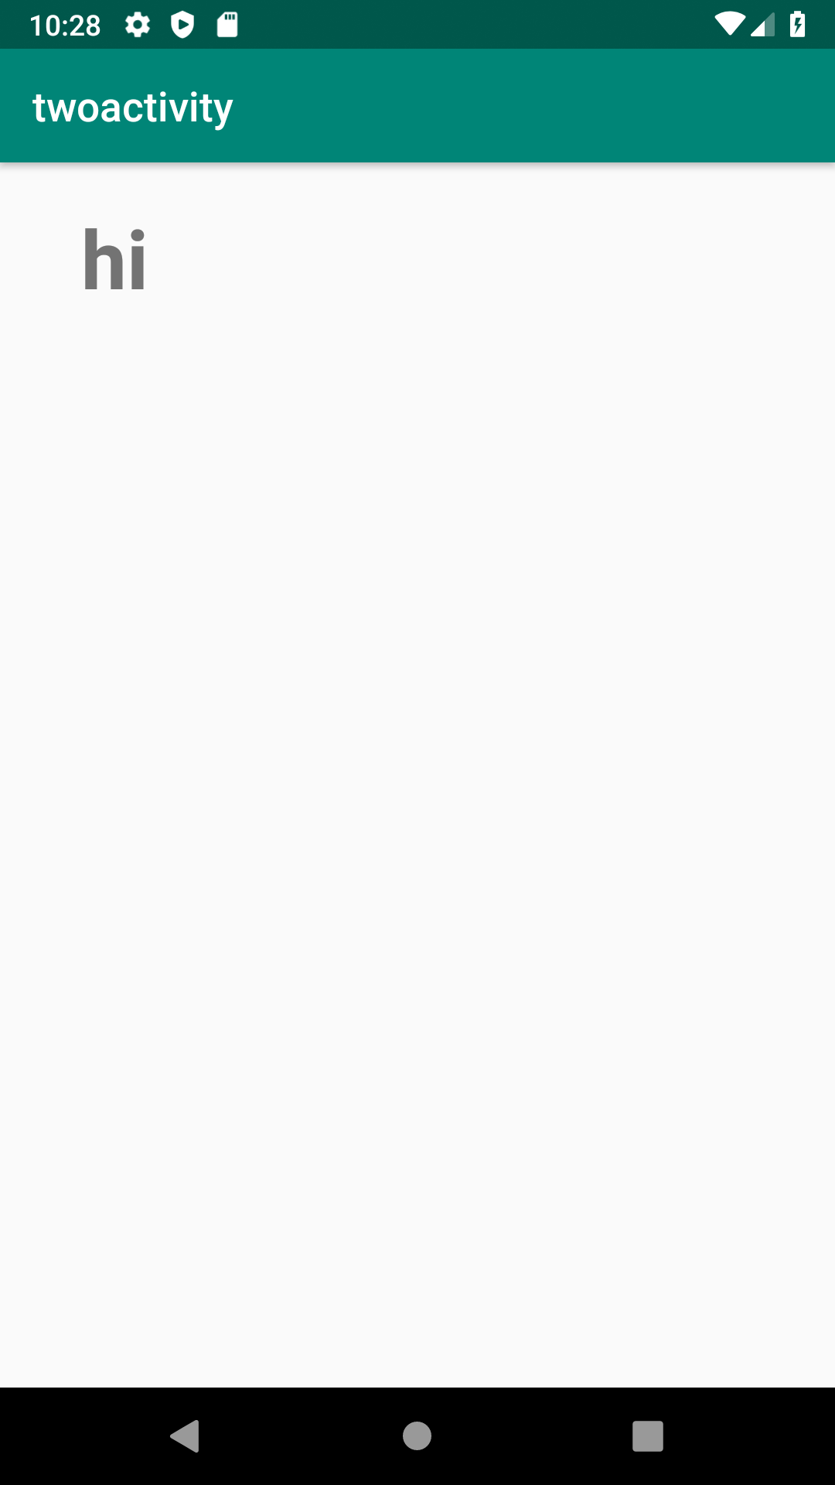

- Create a registration page with full validation and pass the information to the second activity (using shared preference)

Mandatory fields : fname,lname,gender,email,phone number,password,dob(date picker)
code:
xml:
<?xml version="1.0" encoding="utf-8"?>
<LinearLayout xmlns:android="http://schemas.android.com/apk/res/android"
xmlns:tools="http://schemas.android.com/tools"
android:id="@+id/activity_main"
android:layout_width="match_parent"
android:layout_height="match_parent"
android:orientation="vertical"
>
<EditText
android:id="@+id/editTextName"
android:layout_width="match_parent"
android:layout_height="wrap_content"
android:ems="10"
android:hint="Enter First Name"
android:inputType="textPersonName" />
<EditText
android:id="@+id/editTextlName"
android:layout_width="match_parent"
android:layout_height="wrap_content"
android:ems="10"
android:hint="Enter Last Name"
android:inputType="textPersonName" />
<EditText
android:id="@+id/editTextgender"
android:layout_width="match_parent"
android:layout_height="wrap_content"
android:ems="10"
android:hint="Enter Gender"
android:inputType="textPersonName" />
<EditText
android:id="@+id/editTextEmail"
android:layout_width="match_parent"
android:layout_height="wrap_content"
android:ems="10"
android:hint="Enter Email"
android:inputType="textPersonName" />
<EditText
android:id="@+id/editTextMobile"
android:layout_width="match_parent"
android:layout_height="wrap_content"
android:ems="10"
android:hint="Enter Mobile Number"
android:inputType="textEmailAddress" />
<EditText
android:id="@+id/editTextDob"
android:layout_width="match_parent"
android:layout_height="wrap_content"
android:ems="10"
android:hint="Enter Date of Birth (DD/MM/YYYY)"
android:inputType="date" />
<EditText
android:id="@+id/editTextpassword"
android:layout_width="match_parent"
android:layout_height="wrap_content"
android:ems="10"
android:hint="Enter Password"
android:inputType="textPassword" />
<Button
android:id="@+id/buttonSubmit"
android:layout_width="match_parent"
android:layout_height="wrap_content"
android:text="Submit" />
</LinearLayout>
java:
package com.example.sjcet.registrationpage;
import android.content.Intent;
import android.net.Uri;
import android.support.v7.app.AppCompatActivity;
import android.os.Bundle;
import android.text.TextUtils;
import android.util.Patterns;
import android.view.View;
import android.widget.DatePicker;
import android.widget.EditText;
import android.widget.Button;
import android.widget.Toast;
import android.content.SharedPreferences;
public class MainActivity extends AppCompatActivity {
private EditText editTextName, editTextlName,editTextEmail, editTextMobile,
editTextDob, editTextgender,editTextpassword;
private Button buttonSubmit;
@Override
protected void onCreate(Bundle savedInstanceState) {
super.onCreate(savedInstanceState);
setContentView(R.layout.activity_main);
Button btn_Explicit = (Button)findViewById(R.id.buttonSubmit);
editTextName =findViewById(R.id.editTextName);
editTextlName =findViewById(R.id.editTextlName);
editTextEmail =findViewById(R.id.editTextEmail);
editTextMobile =findViewById(R.id.editTextMobile);
editTextDob =findViewById(R.id.editTextDob);
editTextgender =findViewById(R.id.editTextgender);
editTextpassword =findViewById(R.id.editTextpassword);
btn_Explicit.setOnClickListener(new View.OnClickListener() {
@Override
public void onClick(View view) {
checkDataEntered();
SharedPreferences mypref=getSharedPreferences("activity_main2.xml",0);
SharedPreferences.Editor editor=mypref.edit();//only write editor
editor.putString("fname",editTextName.getText().toString()); //bundle the data
editor.putString("lname",editTextlName.getText().toString());
editor.putString("gender",editTextgender.getText().toString());
editor.putString("phone",editTextMobile.getText().toString());
editor.putString("pwd",editTextpassword.getText().toString());
editor.putString("email",editTextEmail.getText().toString());
editor.putString("dob",editTextDob.getText().toString());
editor.commit();
// String str = editTextName.getText().toString();
//String str1 = editTextName.getText().toString();
Intent intent = new Intent(getApplicationContext(), Main2Activity.class);
// intent.putExtra("message_key", str);
startActivity(intent);
}
});
}
boolean isEmail(EditText text) {
CharSequence email = text.getText().toString();
return (!TextUtils.isEmpty(email) && Patterns.EMAIL_ADDRESS.matcher(email).matches());
}
boolean isEmpty(EditText text) {
CharSequence str = text.getText().toString();
return TextUtils.isEmpty(str);
}
void checkDataEntered() {
if (isEmpty(editTextName)) {
Toast t = Toast.makeText(this, "You must enter first name to register!", Toast.LENGTH_SHORT);
t.show();
}
if (isEmpty(editTextlName)) {
editTextlName.setError("Last name is required!");
}
if (isEmpty(editTextMobile)) {
editTextMobile.setError("mobile number is required!");
}
if (isEmpty(editTextgender)) {
editTextgender.setError("Gender is required!");
}
if (isEmpty(editTextpassword)) {
editTextpassword.setError("Password is required!");
}
if (isEmpty(editTextDob)) {
editTextDob.setError("DOB is required!");
}
if (isEmail(editTextEmail) == false) {
editTextEmail.setError("Enter valid email!");
}
}
}
xml:
<LinearLayout android:layout_width="match_parent" android:layout_height="match_parent"
android:orientation="vertical"
android:gravity="center"
xmlns:android="http://schemas.android.com/apk/res/android">
<TextView
android:layout_width="match_parent"
android:layout_height="wrap_content"
android:id="@+id/tv"
/>
</LinearLayout>
java:
package com.example.sjcet.registrationpage;
import android.content.SharedPreferences;
import android.widget.TextView;
import android.content.Intent;
import android.support.v7.app.AppCompatActivity;
import android.os.Bundle;
public class Main2Activity extends AppCompatActivity {
TextView tv;
@Override
protected void onCreate(Bundle savedInstanceState) {
super.onCreate(savedInstanceState);
setContentView(R.layout.activity_main2);
tv =findViewById(R.id.tv);
Intent intent = getIntent();
SharedPreferences mypref=getSharedPreferences("activity_main2.xml",0);
String str = mypref.getString("tv",null);
tv.setText(str);
}
}
output:
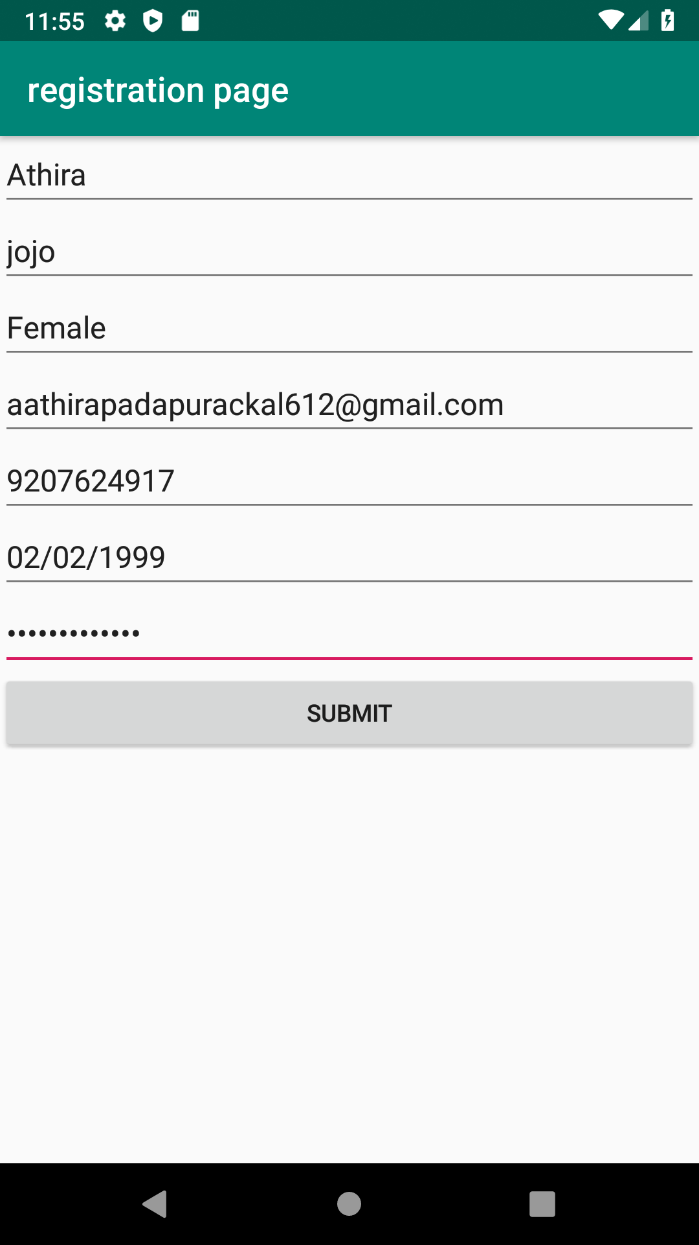

MAD LAB CYCLE 3

- Design a simple login page using relative layout.

Activity_main.xml

<?xml version="1.0" encoding="utf-8"?>
<RelativeLayout
xmlns:android="http://schemas.android.com/apk/res/android"
xmlns:tools="http://schemas.android.com/tools"
android:id="@+id/activity_main"
android:layout_width="match_parent"
android:layout_height="match_parent"
android:background="#00CC99">

<EditText
android:id="@+id/text2"
android:layout_width="match_parent"
android:layout_height="wrap_content"
android:layout_marginLeft="18dp"
android:layout_marginRight="18dp"
android:padding="8dp"
android:background="#fff"
android:hint="Password"
android:layout_marginTop="12dp"
android:layout_below="@+id/text1" />

<Button
android:id="@+id/b1"
android:layout_width="match_parent"
android:layout_height="wrap_content"
android:text="Login"
android:textColor="#00CC99"
android:layout_below="@+id/text2"
android:layout_marginTop="17dp"
android:layout_alignStart="@+id/text2"
android:layout_alignEnd="@+id/text2" />

<TextView
android:layout_width="wrap_content"
android:layout_height="wrap_content"
android:id="@+id/text3"
android:textColor="#fff"
android:text="Not a member?Sign up now"
android:layout_below="@+id/b1"
android:layout_centerHorizontal="true"
android:layout_marginTop="34dp" />
</RelativeLayout>

MainActivity.java

package com.codedost.loginscreen;

import android.support.v7.app.AppCompatActivity;
import android.os.Bundle;

public class MainActivity extends AppCompatActivity {

@Override
protected void onCreate(Bundle savedInstanceState) {
super.onCreate(savedInstanceState);
setContentView(R.layout.activity_main);
}
}

OUTPUT

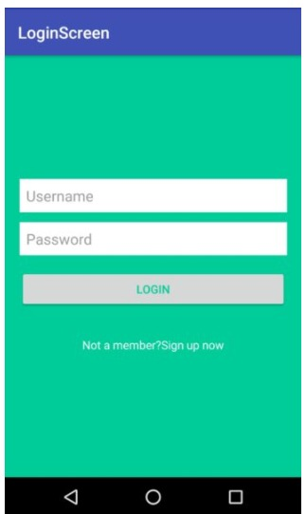

2.Create a Array Adaptor with list view.

activity_main.xml

<?xml version="1.0" encoding="utf-8"?>
<RelativeLayout
xmlns:android="http://schemas.android.com/apk/res/android"
xmlns:tools="http://schemas.android.com/tools"
android:layout_width="match_parent"
android:layout_height="match_parent"
tools:context=".MainActivity">

<ListView
android:id="@+id/simpleListView"
android:layout_width="match_parent"
android:layout_height="wrap_content" />

</RelativeLayout>

item_view.xml

<?xml version="1.0" encoding="utf-8"?>
<LinearLayout
xmlns:android="http://schemas.android.com/apk/res/android"
android:layout_width="match_parent"
android:layout_height="match_parent"
android:orientation="vertical">

<TextView
android:id="@+id/itemTextView"
android:layout_width="match_parent"
android:layout_height="wrap_content"
android:layout_gravity="center" />

</LinearLayout>

MainActivity.java

import android.os.Bundle;
import android.widget.ArrayAdapter;
import android.widget.ListView;
import androidx.appcompat.app.AppCompatActivity;

public class MainActivity extends AppCompatActivity {

ListView simpleListView;

// array objects
String courseList[] = {"C-Programming", "Data Structure", "Database", "Python",
"Java", "Operating System", "Compiler Design", "Android Development"};

@Override
protected void onCreate(Bundle savedInstanceState) {
super.onCreate(savedInstanceState);
setContentView(R.layout.activity_main);

simpleListView = (ListView) findViewById(R.id.simpleListView);

ArrayAdapter<String> arrayAdapter = new ArrayAdapter<String>(this,
R.layout.item_view, R.id.itemTextView, courseList);
simpleListView.setAdapter(arrayAdapter);
}
}

OUTPUT

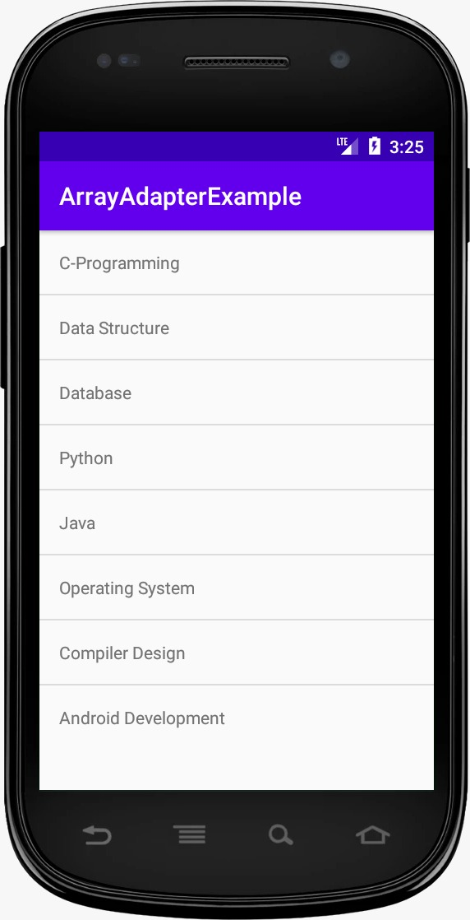

3.Develop an application that toggle image using frame layout.

Activity_main.xml

<FrameLayout xmlns:android="http://schemas.android.com/apk/res/android"
android:layout_width="fill_parent"
android:layout_height="fill_parent">

<ImageView
android:id="@+id/imageview"
android:layout_width="fill_parent"
android:layout_height="fill_parent"
android:scaleType="fitCenter"
android:src="@drawable/piq1" />

<Button
android:id="@+id/next"
android:layout_width="wrap_content"
android:layout_height="30dp"
android:layout_marginBottom="15dp"
android:layout_marginRight="10dp"
android:layout_gravity="bottom|right"
android:paddingTop="2dp"
android:paddingBottom="2dp"
android:background="@drawable/buttonback"
android:textColor="#000000"
android:text="Next" />

</FrameLayout>

MainActivity.java

import android.app.Activity;
import android.os.Bundle;
import android.view.View;
import android.widget.Button;
import android.widget.ImageView;

public class Piqlout extends Activity {

@Override
protected void onCreate(Bundle savedInstanceState) {
// TODO Auto-generated method stub
super.onCreate(savedInstanceState);
setContentView(R.layout.piq);

Button next= (Button) findViewById(R.id.next);

if (next.getText().equals("Next")) {
next.setOnClickListener(new View.OnClickListener() {

@Override
public void onClick(View v) {
// TODO Auto-generated method stub
ImageView img = (ImageView) findViewById(R.id.imageview);

img.setImageResource(R.drawable.piq2);
Button next= (Button) findViewById(R.id.next);
next.setText("Prev");

}
});
}
if (next.getText().equals("Prev")){
next.setOnClickListener(new View.OnClickListener() {

@Override
public void onClick(View v) {
// TODO Auto-generated method stub

ImageView img = (ImageView) findViewById(R.id.imageview);
img.setImageResource(R.drawable.piq1);
Button next= (Button) findViewById(R.id.next);
next.setText("Next");

}
});
}
}
4.Demonstrate activity life cycle.

Activity_main.xml

<?xml version="1.0" encoding="utf-8"?>
<android.support.constraint.ConstraintLayout xmlns:android="http://schemas.android.com/apk/res/android"
xmlns:app="http://schemas.android.com/apk/res-auto"
xmlns:tools="http://schemas.android.com/tools"
android:layout_width="match_parent"
android:layout_height="match_parent"
tools:context="example.javatpoint.com.activitylifecycle.MainActivity">

<TextView
android:layout_width="wrap_content"
android:layout_height="wrap_content"
android:text="Hello World!"
app:layout_constraintBottom_toBottomOf="parent"
app:layout_constraintLeft_toLeftOf="parent"
app:layout_constraintRight_toRightOf="parent"
app:layout_constraintTop_toTopOf="parent" />

</android.support.constraint.ConstraintLayout>

MainActivity.java

package example.javatpoint.com.activitylifecycle;
import android.app.Activity;
import android.os.Bundle;
import android.util.Log;

public class MainActivity extends Activity {

@Override
protected void onCreate(Bundle savedInstanceState) {
super.onCreate(savedInstanceState);
setContentView(R.layout.activity_main);
Log.d("lifecycle","onCreate invoked");
}
@Override
protected void onStart() {
super.onStart();
Log.d("lifecycle","onStart invoked");
}
@Override
protected void onResume() {
super.onResume();
Log.d("lifecycle","onResume invoked");
}
@Override
protected void onPause() {
super.onPause();
Log.d("lifecycle","onPause invoked");
}
@Override
protected void onStop() {
super.onStop();
Log.d("lifecycle","onStop invoked");
}
@Override
protected void onRestart() {
super.onRestart();
Log.d("lifecycle","onRestart invoked");
}
@Override
protected void onDestroy() {
super.onDestroy();
Log.d("lifecycle","onDestroy invoked");
}
}

OUTPUT

You will not see any output on the emulator or device. You need to open logcat.

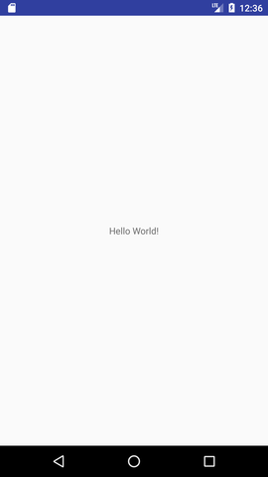

Now see on the logcat: onCreate, onStart and onResume methods are invoked.
Now click on the HOME Button. You will see onPause method is invoked
Now see on the emulator. It is on the home. Now click on the center button to launch the app again.

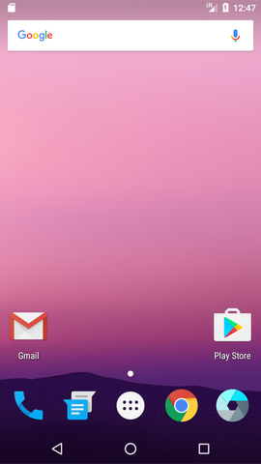

Now click on the lifecycleactivity icon.

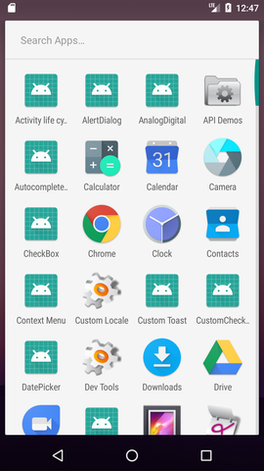

Now see on the logcat: onRestart, onStart and onResume methods are invoked.

If you see the emulator, application is started again.

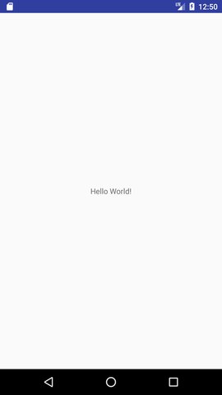

5.Taking camera and saving the picture.

Mainactivity.xml
<?xml version="1.0" encoding="utf-8"?>
<RelativeLayout xmlns:android="https://schemas.android.com/apk/res/android"
xmlns:app="https://schemas.android.com/apk/res-auto"
xmlns:tools="https://schemas.android.com/tools"
android:id="@+id/content_main"
android:layout_width="match_parent"
android:layout_height="match_parent"
android:paddingBottom="@dimen/activity_vertical_margin"
android:paddingLeft="@dimen/activity_horizontal_margin"
android:paddingRight="@dimen/activity_horizontal_margin"
android:paddingTop="@dimen/activity_vertical_margin"
android:background="#000000"
app:layout_behavior="@string/appbar_scrolling_view_behavior"
tools:context="com.journaldev.imagepicker.MainActivity"
tools:showIn="@layout/activity_main">

<RelativeLayout
android:layout_width="250dp"
android:layout_height="250dp"
android:layout_centerHorizontal="true"
android:layout_centerVertical="true"
android:background="@drawable/image_border"
android:clickable="true"
android:orientation="vertical">

<ImageView
android:id="@+id/imageView"
android:layout_width="match_parent"
android:layout_height="match_parent"
android:adjustViewBounds="true"
android:scaleType="centerCrop" />

</RelativeLayout>

<de.hdodenhof.circleimageview.CircleImageView
android:id="@+id/img_profile"
android:layout_width="100dp"
android:layout_height="100dp"
android:layout_gravity="center_horizontal"
android:src="@drawable/profile"
app:civ_border_width="5dp"
app:civ_border_color="#FFFFFF"
android:layout_alignParentBottom="true"
android:layout_centerHorizontal="true" />

</RelativeLayout>

MainActivity.java

public class MainActivity extends AppCompatActivity {

Bitmap myBitmap;
Uri picUri;

private ArrayList permissionsToRequest;
private ArrayList permissionsRejected = new ArrayList();
private ArrayList permissions = new ArrayList();

private final static int ALL_PERMISSIONS_RESULT = 107;

@Override
protected void onCreate(Bundle savedInstanceState) {
super.onCreate(savedInstanceState);
setContentView(R.layout.activity_main);
Toolbar toolbar = (Toolbar) findViewById(R.id.toolbar);
setSupportActionBar(toolbar);

FloatingActionButton fab = (FloatingActionButton) findViewById(R.id.fab);
fab.setOnClickListener(new View.OnClickListener() {
@Override
public void onClick(View view) {
startActivityForResult(getPickImageChooserIntent(), 200);
}
});

permissions.add(CAMERA);
permissionsToRequest = findUnAskedPermissions(permissions);
//get the permissions we have asked for before but are not granted..
//we will store this in a global list to access later.

if (Build.VERSION.SDK_INT >= Build.VERSION_CODES.M) {

if (permissionsToRequest.size() > 0)
requestPermissions(permissionsToRequest.toArray(new String[permissionsToRequest.size()]), ALL_PERMISSIONS_RESULT);
}

}

@Override
public boolean onCreateOptionsMenu(Menu menu) {
// Inflate the menu; this adds items to the action bar if it is present.
getMenuInflater().inflate(R.menu.menu_main, menu);
return true;
}

@Override
public boolean onOptionsItemSelected(MenuItem item) {
// Handle action bar item clicks here. The action bar will
// automatically handle clicks on the Home/Up button, so long
// as you specify a parent activity in AndroidManifest.xml.
int id = item.getItemId();

//noinspection SimplifiableIfStatement
if (id == R.id.action_settings) {
return true;
}

return super.onOptionsItemSelected(item);
}

/**
* Create a chooser intent to select the source to get image from.<br />
* The source can be camera's (ACTION_IMAGE_CAPTURE) or gallery's (ACTION_GET_CONTENT).<br />
* All possible sources are added to the intent chooser.
*/
public Intent getPickImageChooserIntent() {

// Determine Uri of camera image to save.
Uri outputFileUri = getCaptureImageOutputUri();

List allIntents = new ArrayList();
PackageManager packageManager = getPackageManager();

// collect all camera intents
Intent captureIntent = new Intent(android.provider.MediaStore.ACTION_IMAGE_CAPTURE);
List listCam = packageManager.queryIntentActivities(captureIntent, 0);
for (ResolveInfo res : listCam) {
Intent intent = new Intent(captureIntent);
intent.setComponent(new ComponentName(res.activityInfo.packageName, res.activityInfo.name));
intent.setPackage(res.activityInfo.packageName);
if (outputFileUri != null) {
intent.putExtra(MediaStore.EXTRA_OUTPUT, outputFileUri);
}
allIntents.add(intent);
}

// collect all gallery intents
Intent galleryIntent = new Intent(Intent.ACTION_GET_CONTENT);
galleryIntent.setType("image/*");
List listGallery = packageManager.queryIntentActivities(galleryIntent, 0);
for (ResolveInfo res : listGallery) {
Intent intent = new Intent(galleryIntent);
intent.setComponent(new ComponentName(res.activityInfo.packageName, res.activityInfo.name));
intent.setPackage(res.activityInfo.packageName);
allIntents.add(intent);
}

// the main intent is the last in the list (fucking android) so pickup the useless one
Intent mainIntent = allIntents.get(allIntents.size() - 1);
for (Intent intent : allIntents) {
if (intent.getComponent().getClassName().equals("com.android.documentsui.DocumentsActivity")) {
mainIntent = intent;
break;
}
}
allIntents.remove(mainIntent);

// Create a chooser from the main intent
Intent chooserIntent = Intent.createChooser(mainIntent, "Select source");

// Add all other intents
chooserIntent.putExtra(Intent.EXTRA_INITIAL_INTENTS, allIntents.toArray(new Parcelable[allIntents.size()]));

return chooserIntent;
}

/**
* Get URI to image received from capture by camera.
*/
private Uri getCaptureImageOutputUri() {
Uri outputFileUri = null;
File getImage = getExternalCacheDir();
if (getImage != null) {
outputFileUri = Uri.fromFile(new File(getImage.getPath(), "profile.png"));
}
return outputFileUri;
}

@Override
protected void onActivityResult(int requestCode, int resultCode, Intent data) {

Bitmap bitmap;
if (resultCode == Activity.RESULT_OK) {

ImageView imageView = (ImageView) findViewById(R.id.imageView);

if (getPickImageResultUri(data) != null) {
picUri = getPickImageResultUri(data);

try {
myBitmap = MediaStore.Images.Media.getBitmap(this.getContentResolver(), picUri);
myBitmap = rotateImageIfRequired(myBitmap, picUri);
myBitmap = getResizedBitmap(myBitmap, 500);

CircleImageView croppedImageView = (CircleImageView) findViewById(R.id.img_profile);
croppedImageView.setImageBitmap(myBitmap);
imageView.setImageBitmap(myBitmap);

} catch (IOException e) {
e.printStackTrace();
}

} else {

bitmap = (Bitmap) data.getExtras().get("data");

myBitmap = bitmap;
CircleImageView croppedImageView = (CircleImageView) findViewById(R.id.img_profile);
if (croppedImageView != null) {
croppedImageView.setImageBitmap(myBitmap);
}

imageView.setImageBitmap(myBitmap);

}

}

}

private static Bitmap rotateImageIfRequired(Bitmap img, Uri selectedImage) throws IOException {

ExifInterface ei = new ExifInterface(selectedImage.getPath());
int orientation = ei.getAttributeInt(ExifInterface.TAG_ORIENTATION, ExifInterface.ORIENTATION_NORMAL);

switch (orientation) {
case ExifInterface.ORIENTATION_ROTATE_90:
return rotateImage(img, 90);
case ExifInterface.ORIENTATION_ROTATE_180:
return rotateImage(img, 180);
case ExifInterface.ORIENTATION_ROTATE_270:
return rotateImage(img, 270);
default:
return img;
}
}

private static Bitmap rotateImage(Bitmap img, int degree) {
Matrix matrix = new Matrix();
matrix.postRotate(degree);
Bitmap rotatedImg = Bitmap.createBitmap(img, 0, 0, img.getWidth(), img.getHeight(), matrix, true);
img.recycle();
return rotatedImg;
}

public Bitmap getResizedBitmap(Bitmap image, int maxSize) {
int width = image.getWidth();
int height = image.getHeight();

float bitmapRatio = (float) width / (float) height;
if (bitmapRatio > 0) {
width = maxSize;
height = (int) (width / bitmapRatio);
} else {
height = maxSize;
width = (int) (height * bitmapRatio);
}
return Bitmap.createScaledBitmap(image, width, height, true);
}

/**
* Get the URI of the selected image from {@link #getPickImageChooserIntent()}.<br />
* Will return the correct URI for camera and gallery image.
*
* @param data the returned data of the activity result
*/
public Uri getPickImageResultUri(Intent data) {
boolean isCamera = true;
if (data != null) {
String action = data.getAction();
isCamera = action != null && action.equals(MediaStore.ACTION_IMAGE_CAPTURE);
}

return isCamera ? getCaptureImageOutputUri() : data.getData();
}

@Override
protected void onSaveInstanceState(Bundle outState) {
super.onSaveInstanceState(outState);

// save file url in bundle as it will be null on scren orientation
// changes
outState.putParcelable("pic_uri", picUri);
}

@Override
protected void onRestoreInstanceState(Bundle savedInstanceState) {
super.onRestoreInstanceState(savedInstanceState);

// get the file url
picUri = savedInstanceState.getParcelable("pic_uri");
}

private ArrayList findUnAskedPermissions(ArrayList wanted) {
ArrayList result = new ArrayList();

for (String perm : wanted) {
if (!hasPermission(perm)) {
result.add(perm);
}
}

return result;
}

private boolean hasPermission(String permission) {
if (canMakeSmores()) {
if (Build.VERSION.SDK_INT >= Build.VERSION_CODES.M) {
return (checkSelfPermission(permission) == PackageManager.PERMISSION_GRANTED);
}
}
return true;
}

private void showMessageOKCancel(String message, DialogInterface.OnClickListener okListener) {
new AlertDialog.Builder(this)
.setMessage(message)
.setPositiveButton("OK", okListener)
.setNegativeButton("Cancel", null)
.create()
.show();
}

private boolean canMakeSmores() {
return (Build.VERSION.SDK_INT > Build.VERSION_CODES.LOLLIPOP_MR1);
}

@TargetApi(Build.VERSION_CODES.M)
@Override
public void onRequestPermissionsResult(int requestCode, String[] permissions, int[] grantResults) {

switch (requestCode) {

case ALL_PERMISSIONS_RESULT:
for (String perms : permissionsToRequest) {
if (hasPermission(perms)) {

} else {

permissionsRejected.add(perms);
}
}

if (permissionsRejected.size() > 0) {

if (Build.VERSION.SDK_INT >= Build.VERSION_CODES.M) {
if (shouldShowRequestPermissionRationale(permissionsRejected.get(0))) {
showMessageOKCancel("These permissions are mandatory for the application. Please allow access.",
new DialogInterface.OnClickListener() {
@Override
public void onClick(DialogInterface dialog, int which) {
if (Build.VERSION.SDK_INT >= Build.VERSION_CODES.M) {

//Log.d("API123", "permisionrejected " + permissionsRejected.size());

requestPermissions(permissionsRejected.toArray(new String[permissionsRejected.size()]), ALL_PERMISSIONS_RESULT);
}
}
});
return;
}
}

}

break;
}

}
}

